WORKSHEET ON GENETICS FOR KINDERGARTENERS
Created by: Amanda Klopotek

MATERIALS:
-1 yellow marker or crayon
-1 red marker or crayon
-1 orange marker or crayon
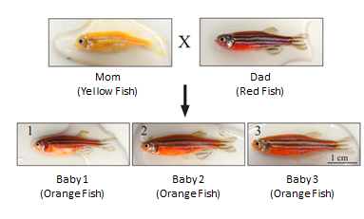
ACTIVITY 1: Color one chromosome yellow and other one chromosome red.
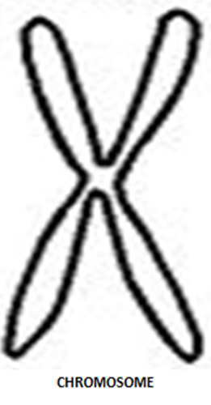
Chromosomes are found in cells that are from both the Mom and Dad. Chromosomes are made of DNA. DNA is a set of instructions that determines the color of these fish. Half of the DNA comes from the Mom and half comes from the Dad. DNA stores all the information needed to make a living thing including people. In humans we get 23 chromosomes from our Mom and 23 chromosomes from our Dad for a total of 46 chromosomes. For this activity we are going to pretend that these fish only have 2 chromosomes and that the chromosomes choose what color the fish will be.
ACTIVITY 2: Follow the coloring instructions under each fish.

ACTIVITY 3:
INSTRUCTIONS:
- Outline each fish in the color it says they are. For example outline the mom fish in yellow, the dad fish in red, and the baby fishes in orange.
- Inside the mom fish color the two X’s yellow
*remember the X’s represent CHROMOSOMES
- Inside the dad fish color two X’s red
4. In each of the baby fish color 1 X red and the other X yellow

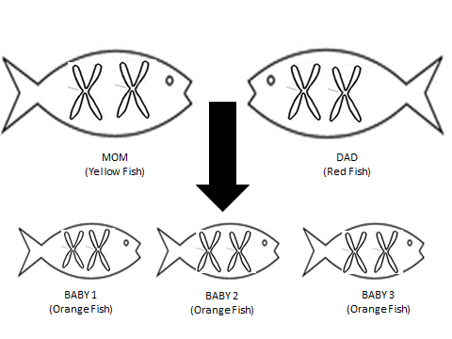

QUESTIONS:

- What do the X’s in each fish represent?

- What are the X’s in each fish made of?

- Where did the baby fish get the red X from?

- Where did the baby fish get the yellow X from?

- If red and yellow are mixed what color do you get?

- Why are the baby fish orange?

ANSWERS TO QUESTIONS:

- Chromosomes
- The chromosomes are made of DNA
- The red “X” came from Dad
- The yellow “X” came from Mom
- Orange
- The baby fish are orange because they received one red X from Dad and one yellow X from Mom. The baby fish all have a red X and a yellow X meaning that they will be orange because when red and yellow are put together you get orange.

